Exercise 09

**Submit the following for the draft:**

1. In a word/text document describe the theme for your game. What is the genre for the game that you will be using (outer space adventure, cave adventure, other)? – Miners Peril.
2. In the text document describe what images you will be using. Will you be using your own that you create or will you be using ones you find from other sites? You can place a few images in the word document as an example for me to see. -- I will be using images from the internet.

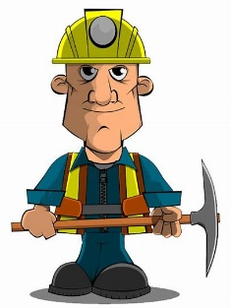

1. In the text document describe which aspects of ES6 you will be incorporating into the game. Let
2. In the text document describe how you may use jQuery with the game. You can also use Greensock animation tools if you'd like. The animation can be part of the interface or the start screen. – Greensock, I will be using it in my start screen.